**Experiment -7**

Aim: To prepare the Software Design Document(SDD) of the Library Management System

What Is Software Design Document (SDD)?

A software product's architecture is described in a software design document (SDD). In the process of software development, it is one of the main document kinds that help to efficiently elaborate. A project manager, software developer, or software designer may write it in detail. It should ideally be a team-wide collaborative document taking in the insights and experiences from everyone. Its goal is to make the software development process easier and to help everyone on the team find their way throughout. Time and money are saved with a well-considered SDD. It serves as a resource for all parties engaged in software development, including clients, technical writers, and QA testers. An SDD helps all parties agree on issues by outlining exactly who is responsible for what.

A highly effective method for creating an SDD is to utilize iterations. This method enables authors to confirm objectives and development plans, gather information more effectively, and receive input from all parties involved.

1.1 PURPOSE

• The purpose of this project is to provide a friendly environment to maintain the details of books and library members.

• The main purpose of this project is to maintain easy circulation system using computers and to provide different reports.

• The Library System is a package to be used by Libraries to improve the efficiency of Librarians, Library employees and Users.

• The system provides books catalogue and information to members and helps them decide on the books to borrow from the library.

• The Librarian can keep the books catalogue updated all the time so that the members get the updated information all the time.

* 1. SCOPE

• The document only covers the requirements specifications for the Library Management System.

• This document does not provide any references to the other component of the Library Management System.

• All the external interfaces and the dependencies are also identified in this document. • The overall scope of the feasibility study is to provide sufficient information to allow a decision to be made as to whether the Library Management System project should proceed and if so, its relative priority in the context of other existing Library Management Technology.

**

**Entity Relationship Diagram**

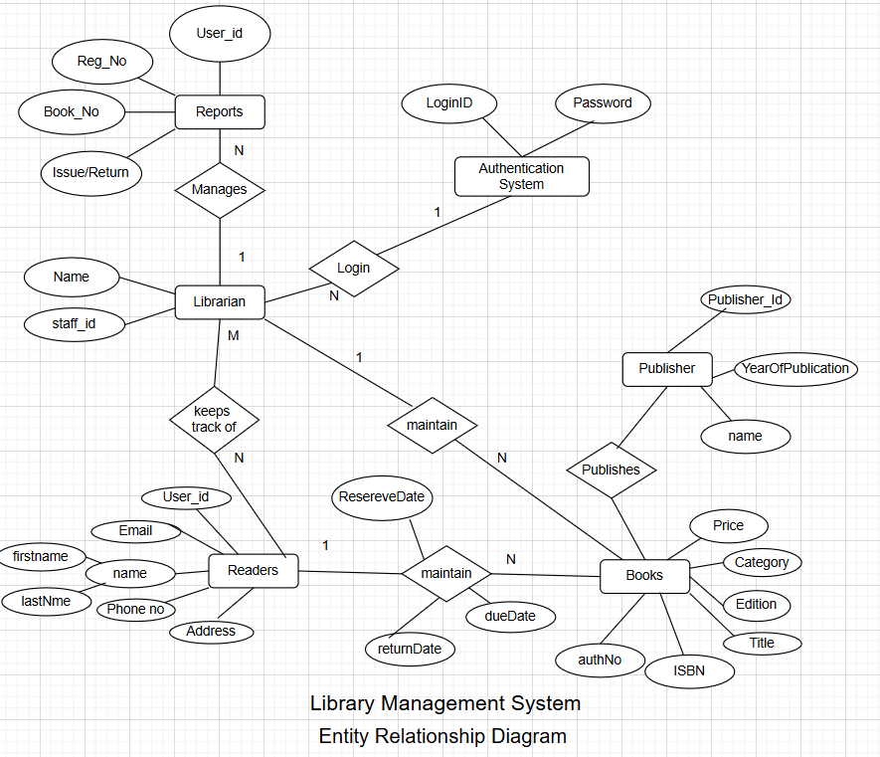

**Entity Descriptions**

|  |  |  |  |  |
| --- | --- | --- | --- | --- |
| **Field Name** | **Data Type** | **Storage** | **Description** | **Constraints** |
| Student_ID | integer | 4 | Unique identifier for each student | Primary Key, Not Null |
| Student_Name | Variable character | 100 | Full name of the student | Not Null |
| Email | Variable character | 100 | Student’s email address | Unique, Not Null |
| PhoneNumber | Variable character | 15 | Student’s contact number | Not Null |
| Course | Variable character | 50 | Course enrolled by the student | Not Null |
| Book_ID | Integer | 4 | Unique identifier for each book | Primary Key, Not Null |
| BookTitle | Variable character | 255 | Title of the book | Not Null |
| Author | Variable character | 100 | Name of the book’s author | Not Null |
| Category | Variable character | 50 | Genre or category of the book | Not Null |
| ISBN | Variable character | 20 | International Standard Book Number | Unique, Not Null |
| Transaction_ID | Integer | 4 | Unique transaction identifier | Primary Key, Not Null |
| Book_ID | Integer | 4 | Book that was borrowed | Foreign Key, References Book Table |
| Student_ID | Integer | 4 | Student who borrowed the book | Foreign Key, References Student Table |
| Issued_Date | Date | 3 | Date when the book was issued | Not Null |
| Due_Date | Date | 3 | Date when the book is due for return | Not Null |
| Return_date | Date | 3 | Date when the book was returned (if returned) | Nullable |
| FineAmt | Decimal | 5 | Fine amount in case of late return | Default = 0.00 |
| Librarian_ID | Integer | 4 | ID of the librarian handling the transaction | Foreign Key, References Librarian Table |